Products List
Structure | Product Name | CAS Number
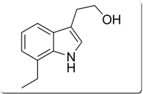 | 7-Ethyl tryptophol | 41340-36-7
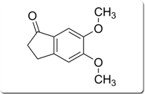 | 5,6-Dimethoxy-1-indanone | 2107-69-9
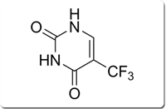 | 5-(trifluoromethyl)uracil | 54-20-6
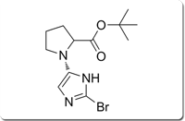 | (S)- tert-butyl-2-(5-bromo-1H-imidazol-2-yl)pyrrolidine-1-carboxylate | 1007882-59-8
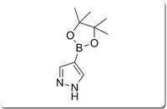 | 4-Pyrazole boronic acid pinacol ester | 269410-08-4
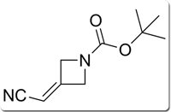 | tert-butyl 3-(cyanomethylidene)azetidine-1-carboxylate | 1153949-11-1
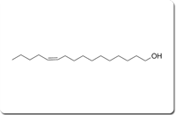 | (Z)-hexadec-11-en-1-ol | 56683-54-6
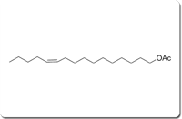 | (Z)-hexadec-11-en-1-yl acetate | 34010-21-4
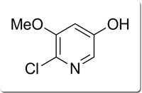 | 6-chloro-5-methoxypyridin-3-ol | 1105933-54-7
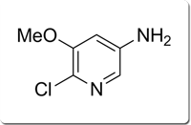 |  | 75711-01-2
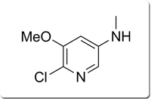 | 6-chloro-5-methoxy-N-methylpyridin-3-amine | 11104455-31-3
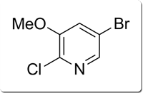 | 5-bromo-2-chloro-3-methoxypyridine | 2286947-03-3
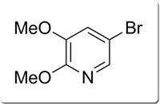 | 5-bromo-2,3-dimethoxypyridine | 552605-98-8
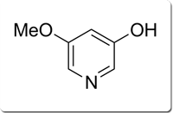 | 5-methoxypyridin-3-ol | 1109345-94-0
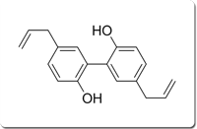 | Magnolol | 528-43-8
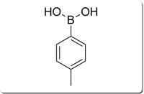 | p-Tolylboronic acid | 5720-05-8
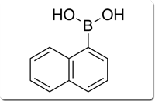 | Naphthale-1-boronic acid | 113922-41-3
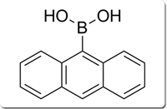 | 9-Anthracene oronic acid | 1100622-34-2
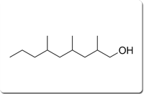 | 2,4,6-trimethylnonan-1-ol, 98% | 883474-29-7
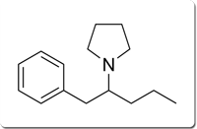 | 1-(1-phenylpentan-2-yl)pyrrolidine | 493-92-5
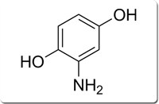 | 2-aminobenzene-1,4-diol | 220734-68-3
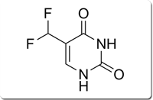 | 5-(Difluoromethyl)uracil | 670-19-9
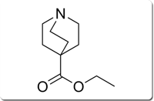 | ethyl quinuclidine-4-carboxylate | 222766-68-3
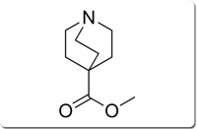 | methyl quinuclidine-4-carboxylate | 551069-26-2
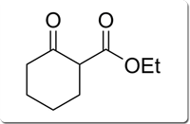 | ) Ethyl 2-oxocyclohexanecarboxylate | 11655-07-8
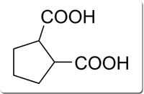 | ) Cyclopentane-1,2-dicarboxylic acid | 550483-99-3
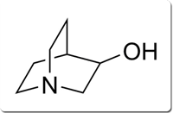 | 3-Quinclidinol | 11619-34-7
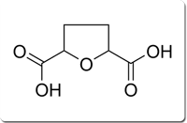 | tetrahydrofuran-2,5-dicarboxylic acid | 66338-43-8
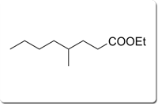 | Ethyl 4-methyloctanoate | 556196-53-3
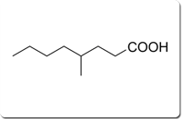 | 4-Methyloctanoic acid | 554947-74-9
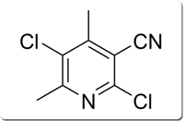 | 2,5-dichloro-4,6-dimethylpyridine-3-carbonitrile | 991591-63-8
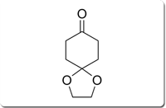 | 1,4-Dioxaspiro[4.5]decan-8-one | 4746-97-8
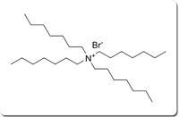 | Tetraheptylammonium bromide | 4368-51-8
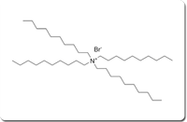 | Tetrakis (decyl)ammonium bromide | 14937-42-9
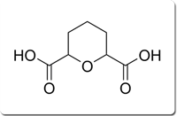 | Tetrahydro-2H-pyran-2,6-dicarboxylic acid | 51673-83-7
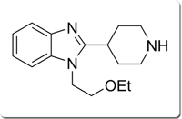 | 1-(2-ethoxyethyl)-2-(piperidin-4-yl)-1H-benzo[d]imidazole | 110963-63-8
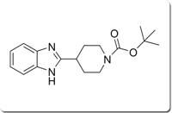 | tert-butyl 4-(1H-benzo[d]imidazol-2-yl)piperidine-1-carboxylate | 953071-73-3
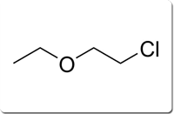 | 1-chloro-2-ethoxyethane | 628-34-2
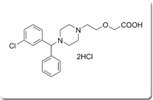 | Cetirizine 3-Chloro Impurity | 1232460-29-5
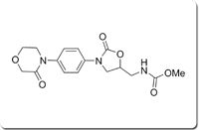 | Rivaroxaban Methyl ester impurity

