Vitamin B Series
Structure | Product Name | CAS Number
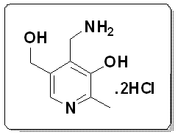 | Pyridoxaminedihydrochloride | 524-36-7
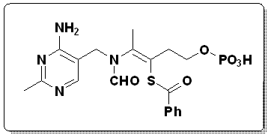 | Benfotiamine | 22457-89-2
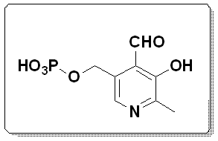 | Pyridoxyl-5-phosphate | 41468-25-1

Neutraceutical
Structure | Product Name | CAS Number
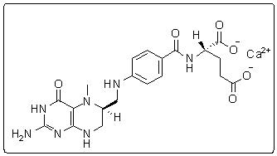 | L-Methylfolate calcium (LMF) | 151533-22-1
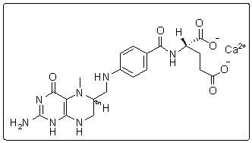 | Methylfolate calcium (CMF) | 26560-38-3

Vitamin K Series
Structure | Product Name | CAS Number
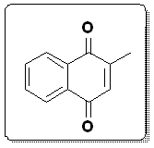 | Menadione | 58-27-5
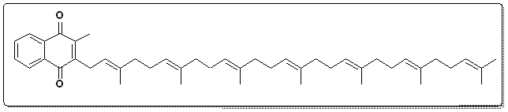 | Menaquinone-7 (MK-7) | 2124-57-4
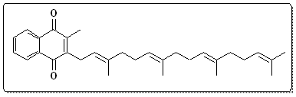 | Menaquinone-4 | 863-61-6
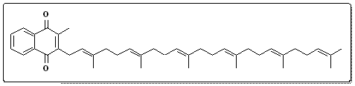 | Menaquinone-6 | 84-81-1
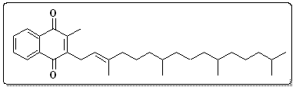 | Phytonadione | 81818-54-4

